931109401767
БЕКЖИГИТОВА Назерке Нуржигитқызы,
№12 ЖББМ ағылшын тілі пәні мұғалімі.
Түркістан облысы, Шардара ауданы

LANGUAGE FOCUS: BE GOING TO AFFIRMATIVE AND NEGATIVE

Learning objectives | 5.3.4.1 respond with limited flexibility at sentence level to unexpected comments on an increasing range of general and curricular topics;  5.6.1.1 use a structure to be going to express intention and plan on a limited range of familiar general and curricular topics;  5.5.3.1 write with support factual descriptions at text level which describe people, places and objects to visit and activities;
Lesson objectives | Learners will be able to:  • Learn and practise be going to affirmative and negative forms.  • Use be going to talk about plans and intentions.
Plan

Stages / Time | Teachers’ actions | Students’ actions | Assessment criteria | Resources
Beginning of the lesson  5 min | Organization moment  1.Greeting.  Ask about the weather.  Warm-up  • Books closed. Ask the class to imagine they have unlimited money and a week to spend it. Ask them to decide on three things they are going to do.  • Put some ideas on the board. Discuss with the class which are the most interesting plans.  Divide into 2 groups.  Teacher gives picturesand divide pupils into two groups.  1st - group -Shanyrak  2nd - group -Dombyra  Home task  Сompleting homework using the «Stopwatch» method  Read the text. Answer the questions  R  Lesson’s topic:  Language Focus: be going to affirmative and negative  Lesson objectives  • Learn and practise be going to affirmative and negative forms.  •Use be going to talk about plans and intentions.  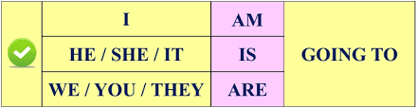  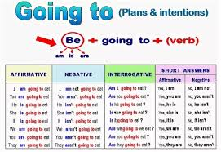 | The aim: To develop Ss speaking skills and create friendly atmosphere  Efficiency: By telling the wishes they show their appreciations .  Students answer the questions.  Focuses on the new lesson | At the organization moment T tries to award active Ss. «The praise» method is used to evaluate Ss with phrases like:  “Good job!  Well done!”  Formative Assessment     | Pictures
Middle of the lesson  Presentation part.  35 min | Ex: 1 P: 59 WB. Individual work method “Word wall”  Students write exersice in Work book and translate  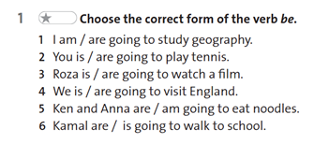  Ex: 2 P:59 WB Group work  • Complete the sentences with going to. Using ‘Poster’ method  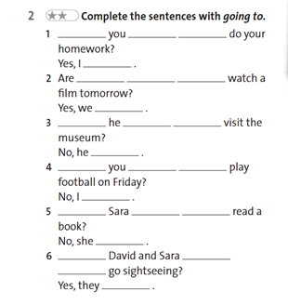  .  Ex: 4 P:59 WB. Pairs work.  Order the words to make questions. “Pictures speak” method  Firs student read the text and translate  Second student make sentence with picture  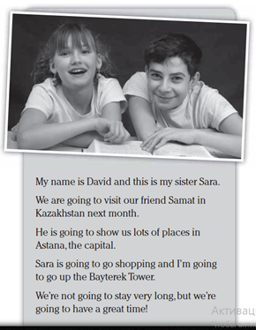 | Students find the forms in the text messages  ANSWERS:  I’m going to study geography.  You are going to play tennis  Rosa is going to watch a film  We are going to visit England  Ken and Anna are going to eat a pizza  Kamel is going to walk to the park  Students read and complete the text with the verbs.  ANSWERS:  1Are you going to do your homework? Yes.Im  2Are you going to watch a film tomorrow?Yes.I,m  3Is he going to visit the museum?No,he isn’t  4Are you going to play football on Friday?No.he isn’t  5.Is Sara going to read a book?No.she isn’t  6.Are David and Sara going to go cinema?Yes.they are  Students answer the questions | Assessment criteria  - Learn and practise be going to affirmative and negative forms.  Descriptor:  - find the forms in the text messages  Formative Assessment  Assessment criteria:  - Use be going to talk about plans and intentions.  Descriptor:  - complete the sentences with the correct words.  Make CCQ questions  Yes / No  Formative Assessment  Formative Assessment |   https://wordwall.net/ru/resource/85125463
End of the lesson  5 min | Home task:  Ex: 4 P: 59 WB  Order the words to make questions. Then read the text and write the answers | 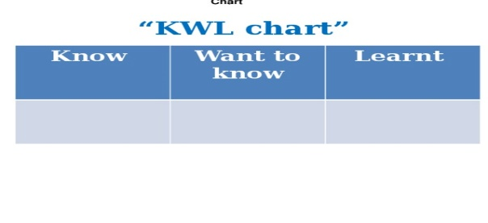 | Students use their stickers to show their knowledge according to the lesson. | Poster  KWL chart  

